# Equalizer quality is a company that specialized in producing wireless headphones “connect through Bluetooth”, you will understand more when you see the GIF.

This logo will appear on the products on packaging and on factory warranty in a form of a small patch. The role of the slogan is to increase customer recall and recognition when the term “beats” is mentioned, and will appear only on product packaging.

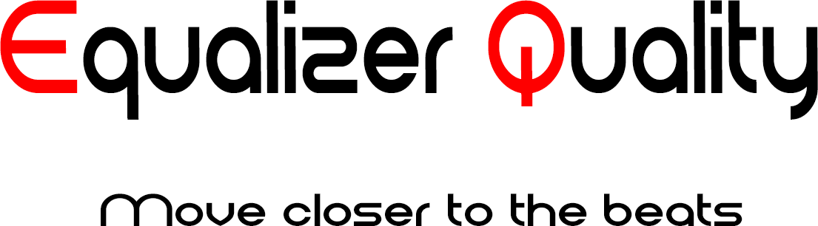

The second logo will appear in the company’s advertising and on products; electronically it moves with beats “same as the equalizer device”, and the slogan used in it will encourage people to obtain more information about the product.

I will send the PSD file to your e-mail because I can’t submit it here…

\***Checkout the brand**

<https://media.giphy.com/media/S52KkpeDJ6Ap0LalZM/giphy.gif>

<https://giphy.com/gifs/S52KkpeDJ6Ap0LalZM/html5>

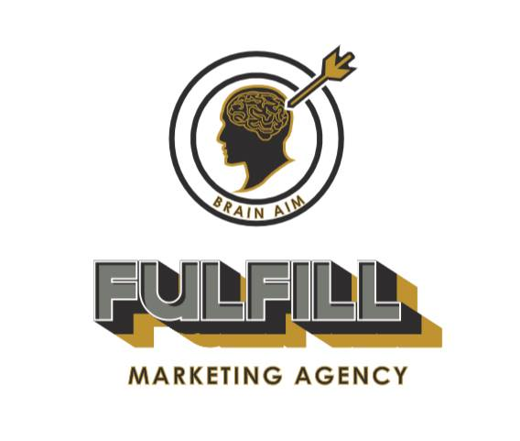

**The first logo design using illustrator (Graduation project).**

Others

AIDA Model advertising:

The First picture represent attention funnel

The second interest

Third desire

Forth action.



